Digital Design Principles

Parking Control System

Name: Rajkaran Singh Grewal

Student No: 8882386

Email: rgrewal2386@conestogac.on.ca

Objective:

- Implementing a solution.  
- Implementing your design in Quartus II, using VHDL file.  
- Connecting your FPGA.

Truth Table:

|  |  |  |  |  |  |  |  |
| --- | --- | --- | --- | --- | --- | --- | --- |
| Sw0 | Sw1 | Sw2 | Sw3 | Sw4 | Sw5 | LEDR | LEDG |
| 0 | 0 | 0 | 0 | 0 | 0 | 0 | 1 |
| 0 | 0 | 0 | 0 | 0 | 1 | 0 | 1 |
| 0 | 0 | 0 | 0 | 1 | 0 | 0 | 1 |
| 0 | 0 | 0 | 0 | 1 | 1 | 0 | 1 |
| 0 | 0 | 0 | 1 | 0 | 0 | 0 | 1 |
| 0 | 0 | 0 | 1 | 0 | 1 | 0 | 1 |
| 0 | 0 | 0 | 1 | 1 | 0 | 0 | 1 |
| 0 | 0 | 0 | 1 | 1 | 1 | 0 | 1 |
| 0 | 0 | 1 | 0 | 0 | 0 | 0 | 1 |
| 0 | 0 | 1 | 0 | 0 | 1 | 0 | 1 |
| 0 | 0 | 1 | 0 | 1 | 0 | 0 | 1 |
| 0 | 0 | 1 | 0 | 1 | 1 | 0 | 1 |
| 0 | 0 | 1 | 1 | 0 | 0 | 0 | 1 |
| 0 | 0 | 1 | 1 | 0 | 1 | 0 | 1 |
| 0 | 0 | 1 | 1 | 1 | 0 | 0 | 1 |
| 0 | 0 | 1 | 1 | 1 | 1 | 0 | 1 |
| 0 | 1 | 0 | 0 | 0 | 0 | 0 | 1 |
| 0 | 1 | 0 | 0 | 0 | 1 | 0 | 1 |
| 0 | 1 | 0 | 0 | 1 | 0 | 0 | 1 |
| 0 | 1 | 0 | 0 | 1 | 1 | 0 | 1 |
| 0 | 1 | 0 | 1 | 0 | 0 | 0 | 1 |
| 0 | 1 | 0 | 1 | 0 | 1 | 0 | 1 |
| 0 | 1 | 0 | 1 | 1 | 0 | 0 | 1 |
| 0 | 1 | 0 | 1 | 1 | 1 | 0 | 1 |
| 0 | 1 | 1 | 0 | 0 | 0 | 0 | 1 |
| 0 | 1 | 1 | 0 | 0 | 1 | 0 | 1 |
| 0 | 1 | 1 | 0 | 1 | 0 | 0 | 1 |
| 0 | 1 | 1 | 0 | 1 | 1 | 0 | 1 |
| 0 | 1 | 1 | 1 | 0 | 0 | 0 | 1 |
| 0 | 1 | 1 | 1 | 0 | 1 | 0 | 1 |
| 0 | 1 | 1 | 1 | 1 | 0 | 0 | 1 |
| 0 | 1 | 1 | 1 | 1 | 1 | 0 | 1 |
| 1 | 0 | 0 | 0 | 0 | 0 | 0 | 1 |
| 1 | 0 | 0 | 0 | 0 | 1 | 0 | 1 |
| 1 | 0 | 0 | 0 | 1 | 0 | 0 | 1 |
| 1 | 0 | 0 | 0 | 1 | 1 | 0 | 1 |
| 1 | 0 | 0 | 1 | 0 | 0 | 0 | 1 |
| 1 | 0 | 0 | 1 | 0 | 1 | 0 | 1 |
| 1 | 0 | 0 | 1 | 1 | 0 | 0 | 1 |
| 1 | 0 | 0 | 1 | 1 | 1 | 0 | 1 |
| 1 | 0 | 1 | 0 | 0 | 0 | 0 | 1 |
| 1 | 0 | 1 | 0 | 0 | 1 | 0 | 1 |
| 1 | 0 | 1 | 0 | 1 | 0 | 0 | 1 |
| 1 | 0 | 1 | 0 | 1 | 1 | 0 | 1 |
| 1 | 0 | 1 | 1 | 0 | 0 | 0 | 1 |
| 1 | 0 | 1 | 1 | 0 | 1 | 0 | 1 |
| 1 | 0 | 1 | 1 | 1 | 0 | 0 | 1 |
| 1 | 0 | 1 | 1 | 1 | 1 | 0 | 1 |
| 1 | 1 | 0 | 0 | 0 | 0 | 0 | 1 |
| 1 | 1 | 0 | 0 | 0 | 1 | 0 | 1 |
| 1 | 1 | 0 | 0 | 1 | 0 | 0 | 1 |
| 1 | 1 | 0 | 0 | 1 | 1 | 0 | 1 |
| 1 | 1 | 0 | 1 | 0 | 0 | 0 | 1 |
| 1 | 1 | 0 | 1 | 0 | 1 | 0 | 1 |
| 1 | 1 | 0 | 1 | 1 | 0 | 0 | 1 |
| 1 | 1 | 0 | 1 | 1 | 1 | 0 | 1 |
| 1 | 1 | 1 | 0 | 0 | 0 | 0 | 1 |
| 1 | 1 | 1 | 0 | 0 | 1 | 0 | 1 |
| 1 | 1 | 1 | 0 | 1 | 0 | 0 | 1 |
| 1 | 1 | 1 | 0 | 1 | 1 | 0 | 1 |
| 1 | 1 | 1 | 1 | 0 | 0 | 0 | 1 |
| 1 | 1 | 1 | 1 | 0 | 1 | 0 | 1 |
| 1 | 1 | 1 | 1 | 1 | 0 | 0 | 1 |
| 1 | 1 | 1 | 1 | 1 | 1 | 1 | 0 |

VHDL Introduction:

To make the program in VHDL we will need to initialize the library and entity. Within the entity we will state the 6 input switches and the two output LEDs. Within the architecture of the program we will state the one output will be assign with AND gate. And the other output will be NAND gate, or to not the first output.

VHDL program screenshot: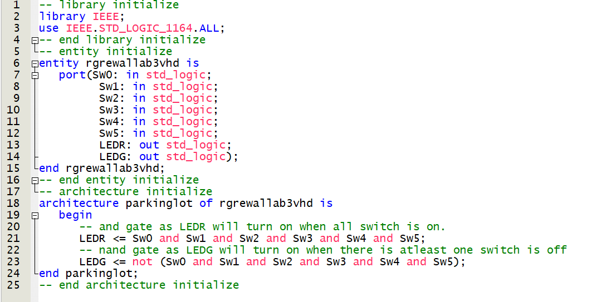

VHDL compilation report: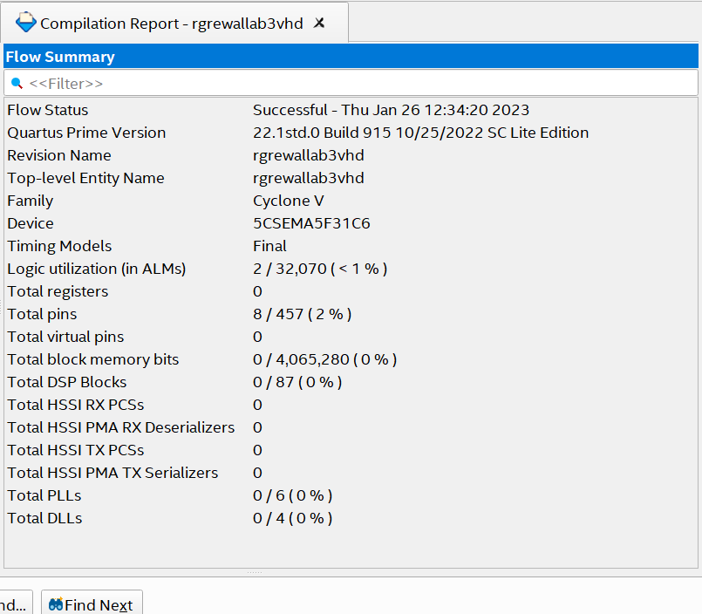

Pin Planner screenshot:

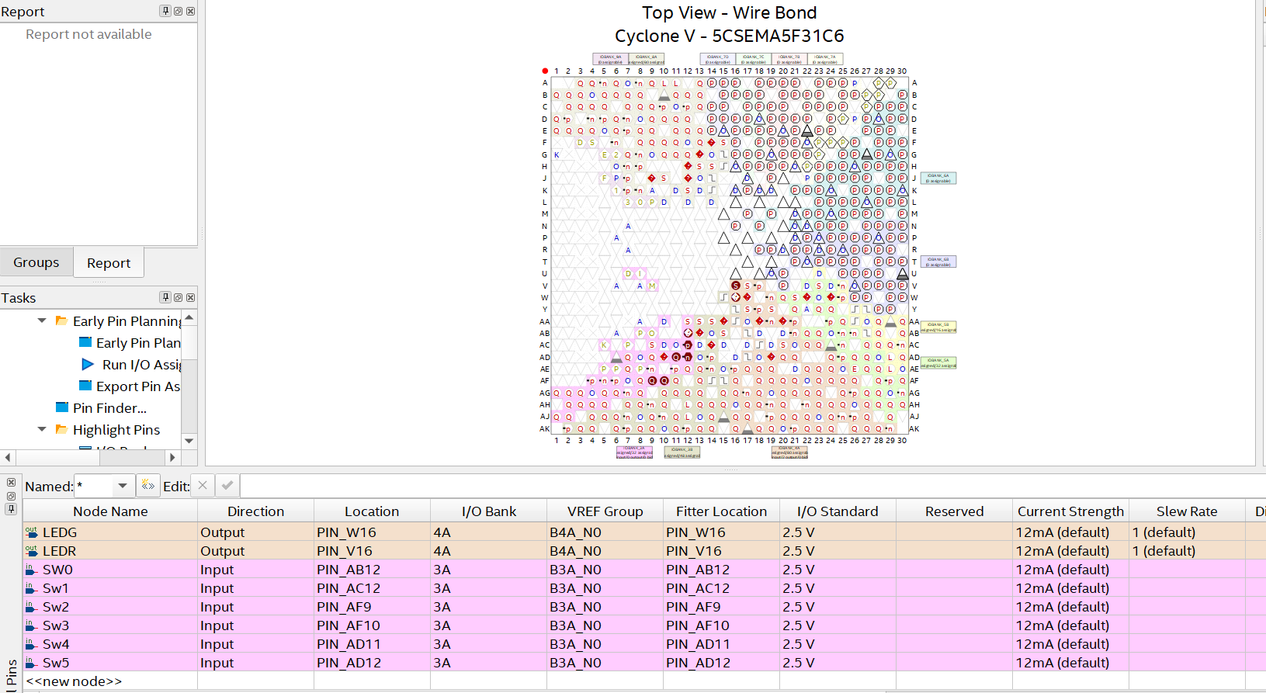

Verilog introduction:

For the program in Verilog we will need to initialize the module with the parameters having the six inputs and two outputs. Within the module block we will assign both LEDs where one LED is and of all the inputs. And the other is not of and of all the inputs. Afterwards we end the module.

Verilog program screenshot: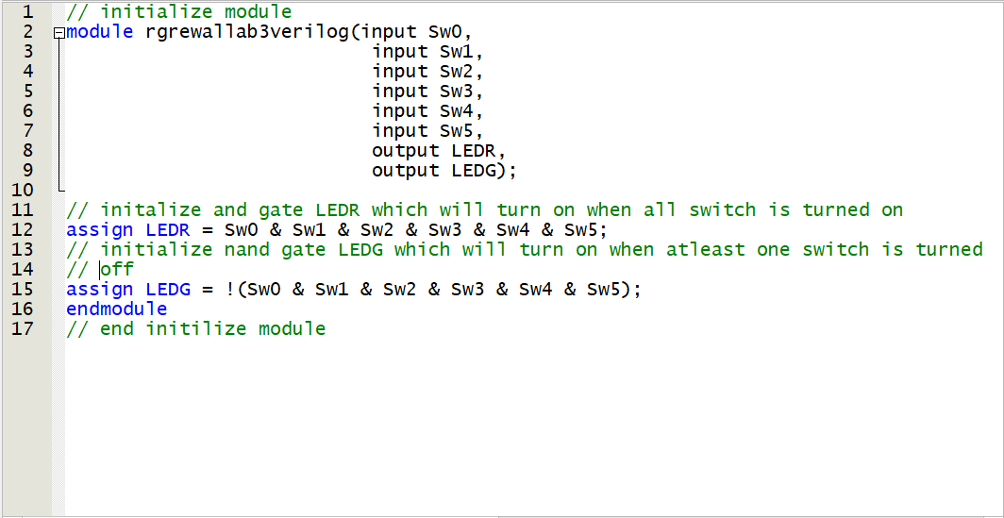

Verilog pin planner screenshot: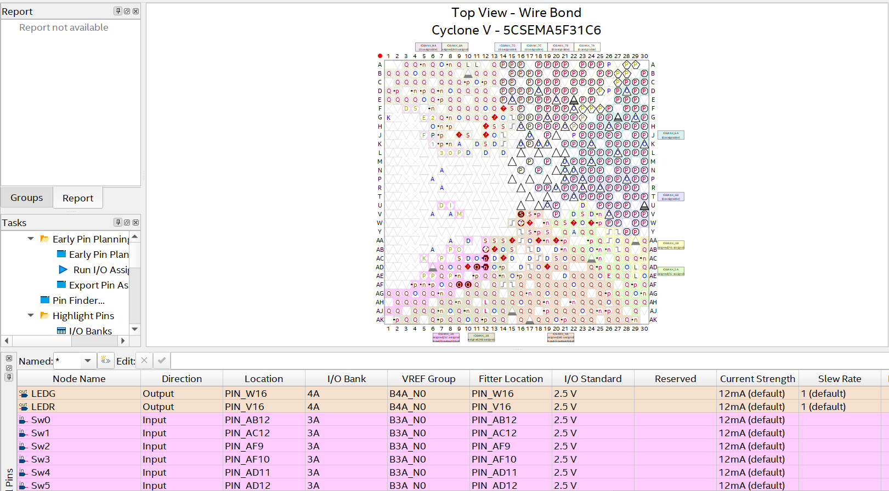

Conclusion:

Thus we can conclude that by both the programming languages we will and all the inputs to see when the red led is lit up and use a not gate for this output to light up the green led.